HEALTHCARE ASSIGNMENTS
This datasets consists of 3 sheets.
- Customers names
- Medical examinations
- Hospitalization details.

SHEET 1:
The sheet 1 is named as CUSTOMR NAMES. this sheet consists of original data and splitted data .
Splitting is done using

DATA TEXT TO COLUMNS DELIMITERS
TABS, COMMAS, OTHERS [.] NEXT
FINISH.

This sheet has NO DUPLICATE DATAS.

SHEET 2:
The sheet 2 is named as MEDICAL EXAMINATION. This sheet consists of original data TABLE and Removed null values and added columns table.
The removed null values , the CUSTOMER ID column has 6 null values. It is changed as “UNKNOWN”.
The new column is created named as WEIGHT STATUS. It is calculated using the bmi column and if function.
=IF(L3<=18.5,”UNDERWEIGHT”,IF(L3<=24.9,”NORMAL”,IF(L3>=29.9,”OVERWEIGHT”,”OBESITY”))).

The other values in the column are filled using flash fill.
The new column is created and named as DIABETES STATUS. This column is calculated using HBA1C column and if function.

=IF(N3<=5.7,”NORMAL”,IF(N3<6.4,”PREDIABETES”,IF(N3>=6.5,DIABETES”))).

the smoker column has 2 null values and its replaced
with unknown.

SHEET 3:
This sheet is named as HOSPITALIZATION DETAILS.
In this sheet 3 columns YEAR,MONTH,AND DATE are merged using CONCAT() function.

=CONCAT(O3,” -“ ,N3,”-“,M3)
Its is came as 12-Oct-1968.

The MONTH column has 3 null values. It is filled with SEP 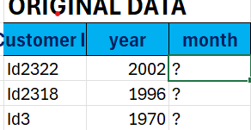
THE year column has 2 null values its changed into its average value 1983.
The hospital tier has 1 null value ,
the city_tier column has 1 null value and
the state-id column has 2 null values.
These null values ar replaced with the relevant values.



the column date of birth is created using text option
=text(y3,”dd/mm/yyyy”).
the age of the patients are calculated using the DATE OF COLLECTION OF DATASET and DATE OF BIRTH column using DATEDIF() function.
=datedif(AE3,AF3,”Y”).
The charges column is formatted into CURRENCY format.

SHEET 4:
This sheet is named as HEALTHCARE.
This sheet has values combined of the other 3 sheets. This is done using vlookup option using the customer id column.
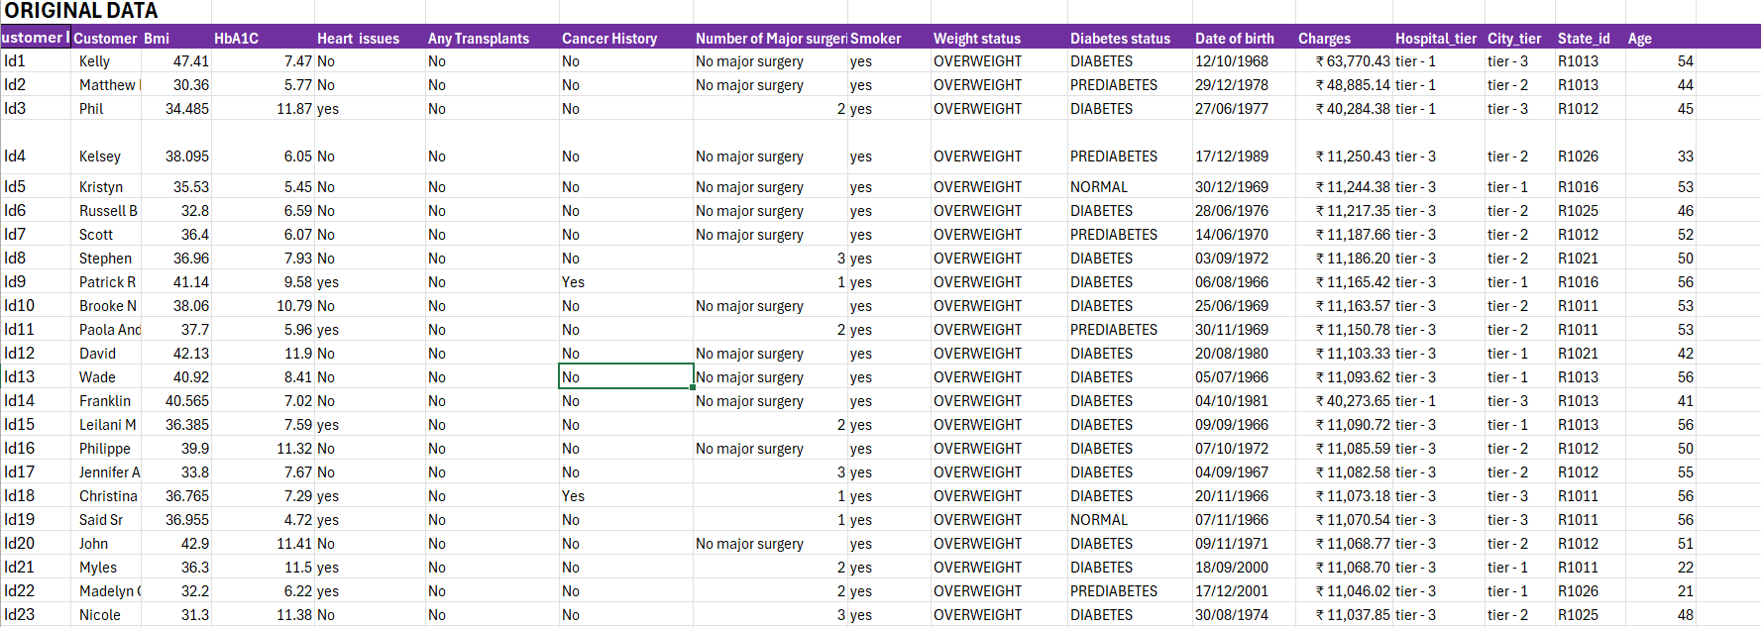
- BMI =VLOOKUP(A3,’MEDICAL EXAMINATION’!K3:T2337,2,FALSE)
- HBA1C =VLOOKUP(A3,’MEDICAL EXAMINATION’!K3:T2337,4,FALSE).
- HEART ISSUES =VLOOKUP(A3,’MEDICAL EXAMINATION’!,K3:T2337,6,FALSE)
- ANY TRANSPLANTS =VLOOKUP(A3,’MEDICAL EXAMINATION’!K3:T2337,7,FALSE)
- CANCER HISTORY =VLOOKUP(A3’MEDICAL EXAMINATION’!K3:T2337,8,FALSE)
- NO.OF SURGERIES =VLOOKUP(A3,’MEDICAL EXAMINATION’!K3:T2337,9,FALSE)
- SMOKER =VLOOKUP(A3,’MEDICAL EXAMINATION’!K3:T2337,10,FALSE)
- WEIGHT STATUS =VLOOKUP(A3,’MEDICAL EXAMINATION’!K3:T2337,3,FALSE)
- DIABETES STATUS =VLOOKUP(A3,’MEDICAL EXAMINATION’!K3:T2337,5,FALSE)
- DATE OF BIRTH =VLOOKUP(A3,’HOSPITALIZATION DETAILS’!X3:AG2337,8,FALSE)
- CHARGES =VLOOKUP(A3,’HOSPITALIZATION DETAILS’!X3:AG2337,4,FALSE)
- HOSPITAL_TIER =VLOOKUP(A3,’HOSPITALIZATION DETAILS’!X3:AG2337,5,FALSE)
- CITY_TIER =VLOOKUP(A3,’HOSPITALIZATION DETAILS’!X3:AG2337,6,FALSE)
- STATE-TIER =VLOOKUP(A3,’HOSPITALIZATION DETAILS’!X3:AG2337,7,FALSE)
- AGE =VLOOKUP(A3,’HOSPITALIZATION DETAILS’!X3:AG2337,10,FALSE)

AVERAGE
COLUMNS | VALUES
BMI | 30.972649
CHARGES | ₹ 13,543.96
HBA1C | 6.5789979
SUM
MAJOR SURGERIES | 1579

SHEET 5:
This sheet is named as PIVOT TABLE.
The pivot tables are created in this sheet.

SHEET 6:
This sheet is named as DASHBOARD.
THE dashboard and the slicers are created in this sheet.
HEALTH CARE SUMMARY:
​Smoking and Cancer:
Smokers show a significantly higher distribution of cancer history compared to non-smokers.
​Transplants and Surgeries:
Patients with transplant history require more major surgeries and maintain higher average HbA1C levels.
​Charges and Health Status:
Healthcare charges are much higher for patients who are both diabetic and overweight.
​Hospital and State Trends:
Average medical charges vary by state, with Tier-1 hospitals charging the highest rates.
​Age and Health Correlation:
As age increases, BMI, HbA1C levels, and overall healthcare costs show a steady rise.
​Final Conclusion: Lifestyle choices and pre-existing health conditions are the primary drivers of healthcare costs.

